Experiment 6A: Acceleration Due To Gravity (Pendulum + Ball Drop)

Group Submission
Madelyn Woodrow, Yoaneli Ortiz, Trung Vo, Patrick Ignaut

PHYS 1401
College Physics -1

2/17/2025

TABLE OF CONTENTS

Objective 3
Equipment 3
Theory and Equations (Pendulum) 3
Theory and Equations (Ball Drop) 3
Procedure (Pendulum) 3
Procedure (Ball Drop) 4
Data and Observations 4
Calculations 6
Results 7
Sources of Error 7
Discussion 8
Conclusion 8

OBJECTIVE:
The objective of this experiment is to find the acceleration due to gravity by using a pendulum and dropping a ball.

EQUIPMENT:
- Ballistic Pendulum | - Stopwatch
- Ball | - Meter Stick

THEORY AND EQUATIONS (PENDULUM):
A mass that is attached to a string forms a simple pendulum. When the mass is pulled to one side and let go, the pendulum swings back and forth. The time that it takes for one complete vibration, going from one end to the other and back to the first, is the time period, T. The time period depends on the acceleration due to gravity, g, and the length of the pendulum. Measuring the length of the pendulum and the time period, g can be found using this equation:
- $T=2π\sqrt{\frac{L}{g}}$
Squaring both sides gives
- $= {4π}^{2}\frac{L}{g}$ or $L = \frac{g}{{4π}^{2}}T^{2}$
If equation 2 is compared to the equation of a straight line y=mx+b, the y intercept ‘b’ is zero, and the slope m is $\frac{g}{{4π}^{2}}$. On a graph of L being the y axis and $T^{2}$ being the x axis, the slope is $\frac{g}{{4π}^{2}}$, which is where the value of ‘g’ can be found.

THEORY AND EQUATIONS (BALL DROP):
When a ball is dropped from a height $y_{i}$ with zero being the initial speed, it falls down with an acceleration -g m/$s^{2}$. If air resistance isn’t included, by measuring the time it takes for the ball to hit the ground, g can be calculated with the equation:
- $y_{f}=y_{i}+v_{yi}(t_{f}-t_{i})+\frac{1}{2}a_{y}{(t_{f}-t_{i})}^{2}$
Where $y_{i}$ is the initial position at time $t_{i}$, $y_{f}$ being the final position at time $t_{f}$ = 0.00m, $v_{yi}$ being the initial velocity in the y direction at time $t_{i}$ = 0.00 m/s, and $a_{y}$ being the constant acceleration in the y direction = -g m/$s^{2}$. The equation can be reduced to:
- 0 = $y_{i}$ + $\frac{1}{2}$(-g)${(t_{f}-t_{i})}^{2}$ or $y_{i}$ = $\frac{1}{2}g{(t_{f}-t_{i})}^{2}$

PROCEDURE (PENDULUM):
- Obtain a mass of around 20 to 50 grams. Attach to the bottom of the ballistic pendulum
- Place the ball inside the ballistic pendulum
- Measure and note the length of the pendulum, which is from the top of the bar to the very bottom of the pendulum
- Pull the pendulum to one side so it makes a 5° angle from the vertical position. Let the mass go.
- Start the stopwatch once the pendulum is let go and count how many vibrations it does before it stops completely. Stop the stopwatch once the pendulum stops moving.
- Plot a graph between length on the x axis and $T^{2}$on the y axis. Find the least square fit line for the data. Use the slope of the line to find the value of g.
PROCEDURE (BALL DROP):
- Hold a meter stick vertically, with the zero touching the ground.
- Hold the ball with its lowest point at 30 cm. Let the ball go.
- Measure the time ‘t’ that the ball took to hit the ground.
- Repeat steps 2 and 3, raising the height of the ball by 20 cm each time.
- Plot a graph between the square of the time $t^{2}$ on the x axis and the height $y_{i}$ on the y axis. Fit a straight line to the data.
- Determine the value of g from the slope. The slope does not equal g.
DATA AND OBSERVATIONS:
Part 1: For the first table, the data was gathered by bringing the pendulum to a 5° angle, and starting the timer when the pendulum was let go.The number of vibrations that occurred were counted until the pendulum came to a stop. Once the pendulum stopped, the timer was stopped and the total vibrations and time were recorded. The time period and time period squared were then calculated.
PENDULUM (10g ball+50g weight)
Length of pendulum, L | Number of vibrations, N | Time for N vibrations, t | Time Period, T = t / N | Time Period squared, T²
35.0 cm | 19 | 22.06 seconds | 1.16 | 1.35
35.0 cm | 20 | 21.78 seconds | 1.09 | 1.19
35.0 cm | 22 | 25.79 seconds | 1.17 | 1.37
35.0 cm | 23 | 27.84 seconds | 1.21 | 1.46
35.0 cm | 16 | 18.13 seconds | 1.13 | 1.28
35.0 cm | 21 | 22.31 seconds | 1.06 | 1.12
Value of slope from the graph: N/A
Value of ‘g’ found: 10.33
Percent error in ‘g’: 5.3%
Table 1: Above are the recorded number of vibrations, time it took, length of the pendulum, and the calculated time period and time period squared. All runs except the final one were done with the 10g ball and 50g weight. The final run was done with just the 10g ball.

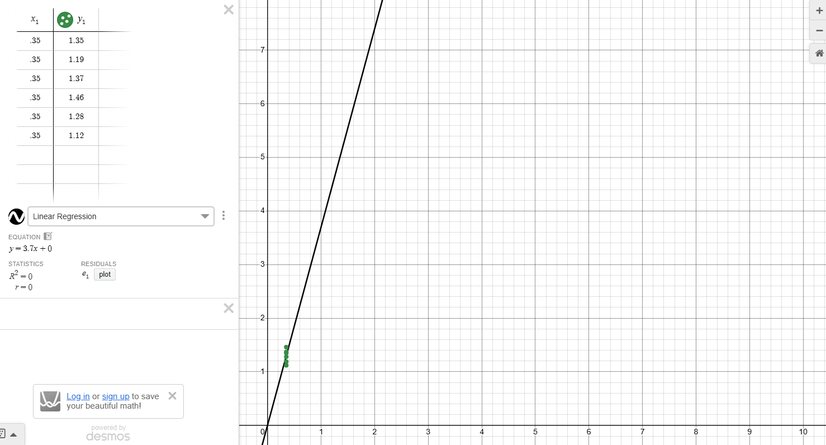
Graph 1: Above is the graph of the gathered data from Table 1. The Y axis is the time period, $T^{2}$, and the X axis is the length of the pendulum, L, in meters.

Part 2: For the second table, 6 total drops were done, with the first one being at 30 cm and each subsequent drop being raised by 20 cm each. The timer was started when the ball was dropped and stopped when the ball hit the ground. The time period squared and the value of g were then calculated.
BALL-DROP (10g ball)
Drop number | Height from where the ball is dropped  y_{i} | Time of fall of ball  t | t² | Calculated value of ‘g’
1 | 30.0 cm | 0.25 s | 0.0625 s² | 9.6
2 | 50.0 cm | 0.33 s | 0.1089 s² | 9.2
3 | 70.0 cm | 0.36 s | 0.1296 s² | 10.8
4 | 90.0 cm | 0.43 s | 0.1849 s² | 9.7
5 | 110.0 cm | 0.50 s | 0.25 s² | 8.8
6 | 130.0 cm | 0.52 s | 0.2704 s² | 9.6
Average value of g: |  |  |  | 9.62
Table 2: Above is the table for the recorded and calculated results of the ball drop trials. The height of the ball and the time it took to fall was recorded, and the time period squared and the value of g were calculated.

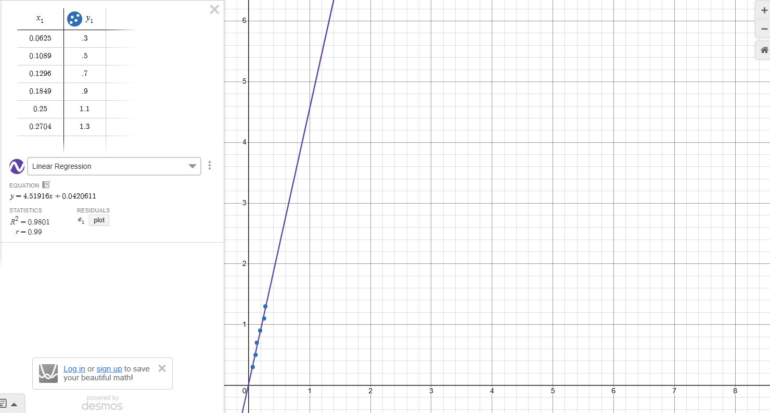
Graph 2: Above is the graph of the gathered data from Table 2. Y is the height the ball was dropped at, y_{i}, in meters. X is the time period squared, t².

CALCULATIONS:
After all the trials were run, the next step was solving all the equations. For the pendulum drop, the length could not be changed, so all 6 runs were measured at 35.0 cm (0.35 m). The ball inside the pendulum weighed 10.0g, and an additional 50.0g weight was added. All trials had the same weight except the very last one, which only had the 10.0g ball. Once the number of vibrations (N) and the time for N vibrations (t) were measured, the first equation used was $T=\frac{t}{N}$. The results of the first equation gave the time period for each time the pendulum would swing. The results would later be squared to give the time period. A graph was made by using Desmos, and it was determined that the graph had no slope due to it being a straight line.The value of ‘g’ was found with the equation $L = \frac{g}{{4π}^{2}}T^{2}$. Since ‘g’ is what’s being solved for, the equation would have to be rearranged to isolate ‘g’. The equation would then become $g={4π}^{2}\frac{L}{T^{2}}$. This resulted in the value of ‘g’ being 10.33 ${m/s}^{2}$. To find the percent error in ‘g’, the equation$\frac{\left|Measured value-True Value\right|}{True Value}*100$ is used. Plugging the numbers in, it comes to $\frac{\left|10.31-9.81\right|}{9.81}*100$, which gives the percent error. When entering these values into a graph ‘X’ would be the length of the pendulum and ‘Y’ would be the time period squared, $t^{2}$. Once these values are entered into the graph it will show a straight line moving in the positive direction.
During the Ball drop portion in the Lab, only a 10.0g ball was used. A total of 6 trials were run, with the first run being from 30.0 cm and being increased by 20.0 cm every run. After every run, the time of the ball falling would increase. The results of the time of fall would be squared to get the squared time for each value. Unlike the pendulum experiment, the value of ‘g’ was needed for each trial individually. To get this value of ‘g’, the equation $\frac{2D}{t^{2}}$ is used. To get the average value of ‘g’, add all 6 values of ‘g’ together and divide that added value by the total number of trials, which is 6. Doing this gives the answer 9.62 ${m/s}^{2}$.
To get the percent error, the equation $\frac{\left|Measured value-True Value\right|}{True Value}*100$ is used. Plugging in the values gives $\frac{\left|9.61667-9.81\right|}{9.81}*100$, with the final answer being 1.97%. To find the percent difference, use the equation $\frac{\left|V_{1}-V_{2}\right|}{\left[\frac{V_{1}-V_{2}}{2}\right]}*100$. After solving the equation, the percent difference is given.

RESULTS:
Pendulum:
Value of slope from the graph: N/A
Value of ‘g’ found: 10.33
Percent error in ‘g’: 5.3%

Ball drop:
Value of slope from the graph: 4.52
Value of ‘g’ found from the slope: 9.62
Percent error in ‘g’: 1.97%
Percent difference in the two values of ‘g’: 7.12%

SOURCES OF ERROR:
- The table would sometimes shake slightly due to people moving around the room
- Recorded time may be off slightly due to differing reaction times
- Using a phone as the stopwatch may cause delay in pressing stop or go depending on sensitivity of the touch screen

DISCUSSION:
The first experiment that will be discussed is the pendulum experiment. Normally, the length of the string would be increased with each trial, but since the length of the pendulum was unable to be changed, instead the goal was to be as accurate as possible with the results. Generally, as the number of vibrations increased, so did the time. The results gathered did allow for the calculation of acceleration due to gravity. The results gathered don’t fully line up with the true value of ‘g’, 9.81, this was caused most likely by the gathered data having two outliers, which resulted in a ‘g’ value of 10.33. Most of the data was close to each other, being within the 20-23 vibrations range, but there was one run that only had 16 vibrations and another run with 19 vibrations. Those two runs most likely caused the data to become skewed and throw off the calculated ‘g’ value. What most likely caused the 2 outlier runs was extra vibrations being created from people walking around the room, and the table itself moving very slightly due to writing being done and things slightly shifting around. Looking at the times measured, they are all close to each other, being in a 21 to 27 second range, but the run with only 16 vibrations had a smaller time that was not in the range. The biggest change that could be made to make the experiment more accurate is to do the experiment in an empty room, since vibrations caused by people walking around is what threw off the results. In an empty room, there wouldn’t be people walking around, so it would allow for better and more accurate results.
The next experiment that will be discussed is the ball drop experiment. The results gathered showed that as the distance the ball was dropped increased, so did the time it took for the ball to hit the ground. The results gathered from the ball drop allowed for the calculation of acceleration due to gravity, and the calculations were relatively close to the true value of gravity, 9.81. The calculated ‘g’ value from all the runs of the ball drop were close to the true value of ‘g’, with only 2 being outliers. Those outliers most likely caused the calculated value of ‘g’ to be slightly off. The two outliers were a calculated ‘g’ value of 10.8 and a calculated ‘g’ value of 8.8. These were most likely caused by the time being slightly off due to reaction times of the people recording the time. To account for this, we had 2 people timing the ball drop, and the time that matched more closely with the already recorded data was used. An inconsistency that can be seen is with all the times, with most of them being around 7 seconds away from each other. With run 3 and 5, however, these times are only 2-3 seconds apart from previous recorded times. To improve the timing of the ball drop, a stopwatch can be used instead of a cell phone, since a stopwatch is easier to use and there isn't as much worry in regards to touch screen sensitivity or missing the start or stop button.

CONCLUSION
The objective of the experiment was to be able to calculate the acceleration due to gravity by using a pendulum and a ball drop. The objective of the experiment was met successfully by following the instructions given and performing multiple trials. The calculated value of ‘g’ as found in the pendulum experiment was somewhat off from the true value of ‘g’, most likely due to extra vibrations caused by people walking around and the table itself moving slightly due to movement. The percent error was calculated, and it was within acceptable limits, which is less than 10%. The calculated value of ‘g’ found in the ball drop experiment was close to the true value of ‘g’, and any discrepancies were most likely caused by differing reaction times and a phone being used instead of a proper stopwatch. The percent error was calculated and it was within acceptable limits. The percent difference between the two ‘g’ values was calculated. This was most likely caused by the ball drop having differing heights, but the pendulum had to be at the same height every run.

